Multiple-choice section – choose the correct answer

Question 1 [4.1]

The perimeter of the rectangle below is:

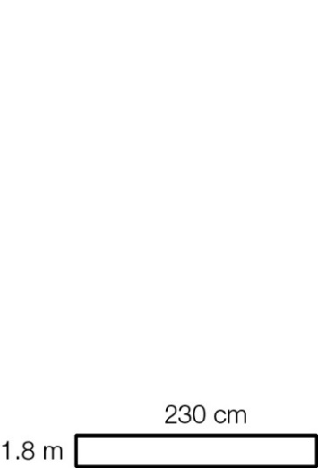

A 82 m B 8.2 m C 4.1 m D 802 cm

Question 2 [4.1]

The arc length of the shaded sector below, correct to 2 decimal places, is:

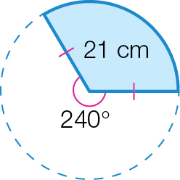

A 43.98 cm B 50.26 cm C 75.4 cm D 12 cm

Question 3 [4.1]

The perimeter of the compound shape below (to 2 decimal places) is:

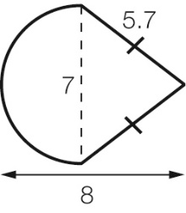

A 18.4 cm B 33.39 cm C 26.6 mm D 22.40 cm

Question 4 [4.2]

35 500 mm2 is equivalent to:

A 35.5 m2 B 0.355 m2 C 0.0355 m2 D 0.003 55 m2

Question 5 [4.2]

What is the area of the semicircle below (to 2 decimal places)?

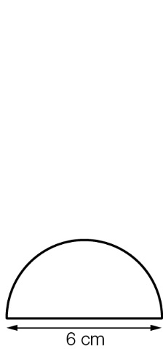

A 113.1 cm2 B 18.85 cm2 C 12 cm2 D 14.14 cm2

Question 6 [4.2]

The area of the shaded region is:

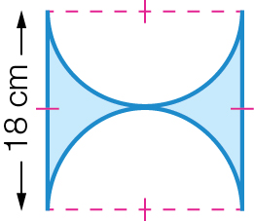

A (18 × 18) – (π × 182) cm2 B (18 × 18) – (π × 92) cm2

C (18 × 18) + (π × 182) cm2 D (18 × 18) – (× π × 92) cm2

Question 7 [4.3]

The surface area of the solid below is:

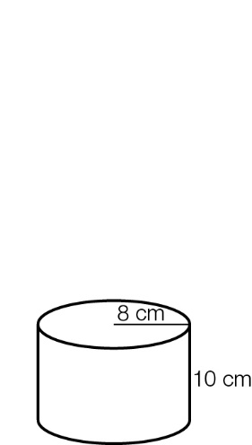

A π × 82 + 2 × π × 8 × 10 cm2 B 2 × π × 82 + 2 × π × 8 × 10 cm2

C 2 × π × 162 + 2 × π × 8 × 10 cm2 D 2 × π × 82 + π × 8 × 10 cm2

Question 8 [4.3]

The surface area of the square-based pyramid below is:

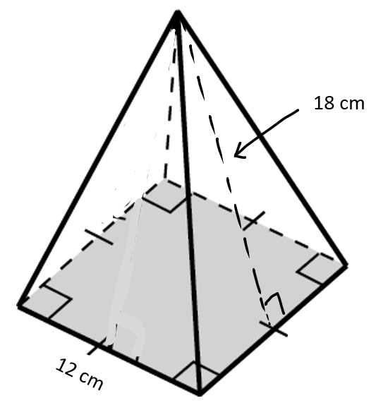

A 576 cm2 B 1008 cm2 C 864 cm2 D 648 cm2

Question 9 [4.4]

74 400 cm3 is equivalent to:

A 7.44 m3 B 0.007 44 m3 C 744 m3 D 74.4 L

Question 10 [4.4]

The volume of this prism is:

**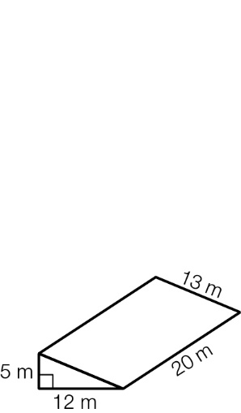**

A × 12× 5 × 13m3 B 12 × 5 × 10m3 C × 12 × 5 × 20m3 D × 12 × 13 × 20m3

Multiple-choice results: \_\_\_ / 10

Short answer section

Question 11 4 marks [4.1]

Calculate the perimeter of the following shapes (to 2 decimal places where necessary).

|  |  |
| --- | --- |
| (a)  ACPM9_PR_4_09ta | (b)  ACPM9_PR_4_10ta |

Question 12 4 marks [4.1, 4.2]

Calculate the perimeter and the area of the shape below, correct to 2 decimal places.

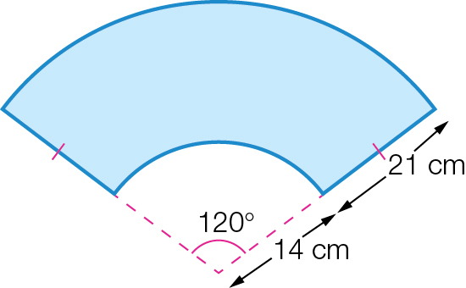

Question 13 2 marks [4.1]

A box is built to contain 12 tennis balls. If the radius of each tennis ball is 5 cm, find the perimeter of the smallest possible rectangle that will contain the balls.

Question 14 3 marks [4.2]

Complete the following area conversions.

(a) 6.5 m2 = \_\_\_\_\_\_\_\_\_\_\_\_\_\_\_ mm2

(b) 0.25 ha = \_\_\_\_\_\_\_\_\_\_\_\_\_\_\_\_\_\_\_\_ m2

(c) 8 950 000 cm2 = \_\_\_\_\_\_\_\_\_\_\_\_\_\_\_ ha

Question 15 6 marks [4.2]

Find the shaded areas of the following composite shapes, to 2 decimal places.

(a)

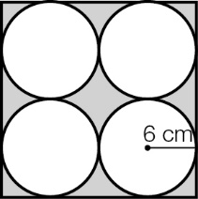

(b)

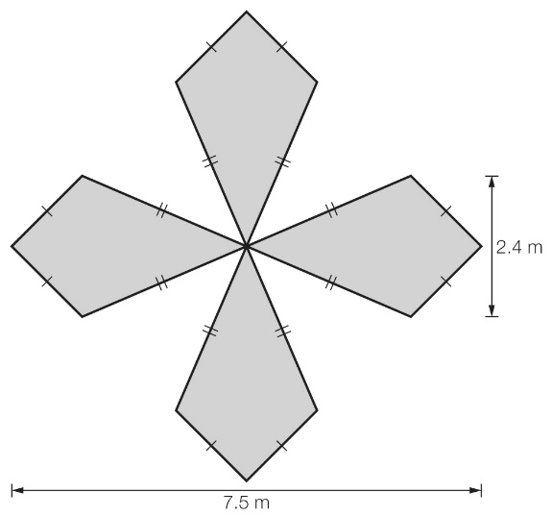

Question 16 4 marks [4.3]

Find the surface area of the following solids, to 2 decimal places.

(a)

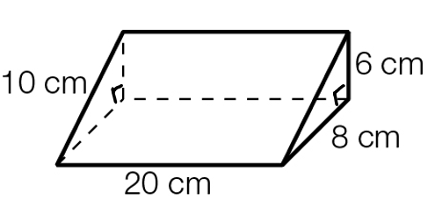

(b)

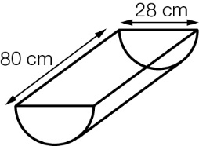

Question 17 4 marks [4.4]

Find the capacity of each of these solids in litres, to 2 decimal places.

|  |  |
| --- | --- |
| **(a)** | **(b)** |

Question 18 3 marks [4.4]

Find the volume of the concrete required to make this hollow pipe, correct to 2 decimal places.

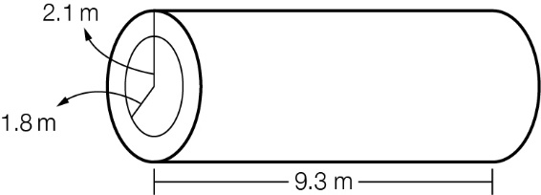

Short answer results: \_\_\_ / 30

Extended answer section

Question 19 6 marks [4.1, 4.2, 4.3]

A cylindrical birthday cake, which has a diameter of 20 cm and a height of 9 cm, is cut into 12 equal-size pieces.

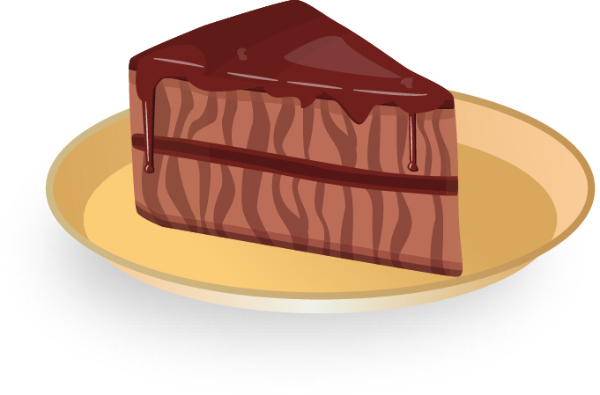

(a) What is the interior angle of each piece of cake?

(b) What is the arc length of one piece of cake?

(c) What is the total surface area of a piece of cake?

Question 20 11 marks [4.4]

Cameron has decided to dig up a hole for a swimming pool in his backyard. He is using a wheelbarrow (with dimensions outlined in the diagram below) to move the dirt out to the front of his house where a local garden supplies company will pick it up.

Unless stated otherwise, round your answers to 2 decimal places.

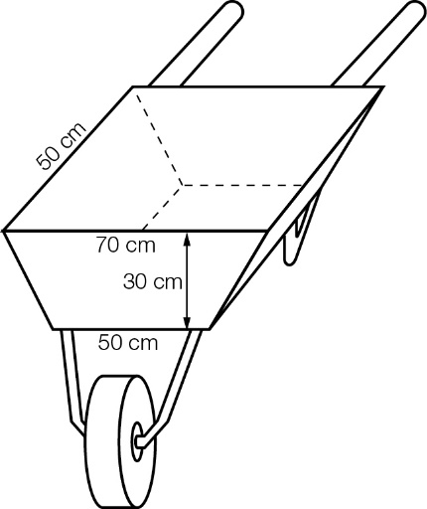

(a) If the wheelbarrow is filled level to its top, what volume of soil can it carry, in cubic metres?

(b) Cameron wants his swimming pool to have the dimensions as shown in the diagram below.Calculate the volume of soil that has to be removed to fit the pool.

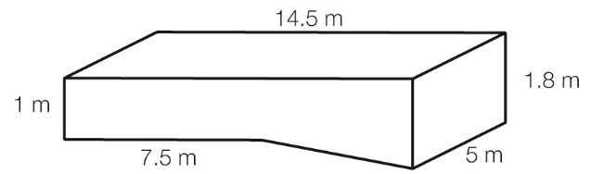

(c) How many trips are required with the wheelbarrow?

(d) Green Thumb Garden Supplies have agreed to pick up the soil in their tip truck. If it has a tray that is 8 m long, 3.8 m wide and 1.8 m high, how many trips will it need to make?

(e) If the pool is filled 10 cm below its rim, how many litres of water is the pool?

Extended answer results: \_\_\_ / 17

TOTAL test results: \_\_\_ / 57